**Lecture 1**

**Types of specimens**: a variety of specimens are used in biochemical analysis:

**1. Body fluids** such as

i- Blood:

a. Serum: is obtained from coagulated blood without anticoagulant then a wait of 15 to 30 min for completion of coagulation then centrifuge the sample.

b. Plasma: anticoagulant is added to the specimen and centrifugation can be done immediately after collection.

ii- Urine.

iii- Spinal fluid.

iv- Amniotic fluid.

v- Peritoneal fluid.

vi- Sputum & saliva.

vii- Synovial (joint fluid).

**2. Feces.**

**3. Tissue and cells.**

**4. Calculi (stones) and other materials.**

**Types of Anticoagulants:**

1. **Ethylenediaminetetraacctic Acid (EDTA)**: The chelating agent EDTA is particularly useful for hematological examinations because it preserves the cellular components of blood. It is used as the disodium or dipotassium salt. EDTA prevents coagulation by binding calcium, which is essential to the clotting mechanism.
2. **Sodium Fluoride**: Sodium fluoride is usually considered a preservative for blood glucose; however, it also acts as a weak anticoagulant. It exerts its preservative action by inhibiting the enzyme systems involved in glycolysis.
3. **Citrate**: Sodium citrate solution is widely used for coagulation studies, because its effect is easily reversible by addition of Ca+2. It appears to preserve labile procoagulants, but it has little application in clinical chemistry.
4. **Heparin**: Heparin causes the least interference with tests. It is a mucoitin polysulfuric acid and is available as sodium, potassium, lithium, and ammonium salts. This anticoagulant accelerates the action of antithrombin III, which neutralizes thrombin and thus prevents the formation of fibrin from fibrinogen.
5. **Oxalates**: Sodium, potassium, ammonium, and lithium oxalates inhibit blood coagulation by forming rather insoluble complexes with calcium ions.
6. **Iodoacetate**: Sodium iodoacetate at a concentration of 2 g/L is an effective antiglycolytic agent and a substitute for sodium fluoride. Because it has no effect on urease, it can be used when glucose and urea assays are performed on a single specimen. It inhibits creatine kinase but appears to have no other significant effects.

**Blood separation:**

Blood is a living tissue composed of several blood cells in plasma. Plasma is the liquid component of blood, which composed of mostly water (90% by volume), and contains dissolved proteins, glucose, clotting factors, mineral ions, hormones and carbon dioxide (plasma being the main medium for excretory product transportation). The cellular elements of blood are red blood cells (RBCs), platelets, and white blood cells. Blood can be separated into plasma layer (55 % of the volume of whole blood), platelet and leukocyte layer (1 % of the volume of whole blood), and RBC layer (45 % of the volume of whole blood) (Fig. 1).

Plasma is the supernatant fluid obtained when anti-coagulated blood has been centrifuged. The blood is mixed with an appropriate amount of anticoagulant. This preparation should be mixed immediately and thoroughly to avoid clotting. Blood serum is blood plasma without fibrinogen or the other clotting factors. Serum is clearer than plasma because of fewer proteins. Proteins are sometimes considered as interfering substances in some tests as they react with the reagent and thereby yield inaccurate results. Serum is the preferred specimen in clinical testing as the interference that may be caused by a plasma specimen because of the presence of an anticoagulant, is eliminated.



**Fig 1: Blood separation**

**Storage of blood specimens:**

1) Plasma or serum should be separated from cells as soon as possible and certainly within 2 hrs to minimize the metabolism of cells.

2) If it's impossible to centrifuge a blood specimen within 2 hrs the specimen should be kept at room temperature rather than at 4 °C to minimize hemolysis.

3) If the specimen can't be analyzed at once, the separated serum should be generally stored in capped tubes at 4 °C until analysis both to:

i- Maintain stability of the specimen; and

ii- Reduce evaporation.

4) If a specimen for a particular test is sufficiently unstable at 4 °C, the serum specimen should be held at – 20 °C in a freezer capable of maintaining this temperature.

5) Specimens for bilirubin or carotene must be protected from both daylight and fluorescent light to avoid photodegradation.

6) Specimen tubes should be centrifuged with stoppers in place. Closure lowers evaporation and prevents aerosolization of infectious particles.

7) Removal of the stopper before centrifugation allow loss if CO2 and increase in blood PH.

**Changes in blood metabolites on keeping:**

1. Glucose is converted to lactate, as a result of glycolysis occurring in blood cells specially RBCs. It's inhibited by fluoride but fluoride interferes with glucose oxidase and urease methods.

2. Glycolysis decreases serum glucose by approximately 5 – 7 % in 1 hr. (5 – 10 mg /dl) in uncentrifuged coagulated blood at room temperature.

3. The rate of glycolysis is higher in the presence of leukocytosis or bacterial contamination.

4. Several substances pass through RBCs membrane e.g. K+, LDH.

5. Loss of CO2, since the PCO2 of blood is much higher than air leading to fall in plasma total CO2.

6. Phosphate increases due to hydrolysis of organic ester phosphate compounds of erythrocytes.

7. Enzymes activities are lost on long keeping

8. Formation of ammonia from nitrogenous substances.

**Lecture 2**

**Spectrophotometer**

Colorimetry is the science that deals with the measurement of the capacity of a chemical, colored system to absorb light. Since, it makes specific quantitative measurements; it is very useful and widely used in laboratories in the form of colorimeter or spectrophotometer. To understand colorimetry, it is essential to have some knowledge and understanding of what is meant by Light, Color, Beer's Law and Lambert’s Law.

**Light:** is a form of energy (radiant energy. It moves in space in the form of waves like the electromagnetic waves. The distance between two identical points on a wave cycle is called the wavelength (λ) (Fig. 2). The unit of measure for wavelength is nanometer (nm).

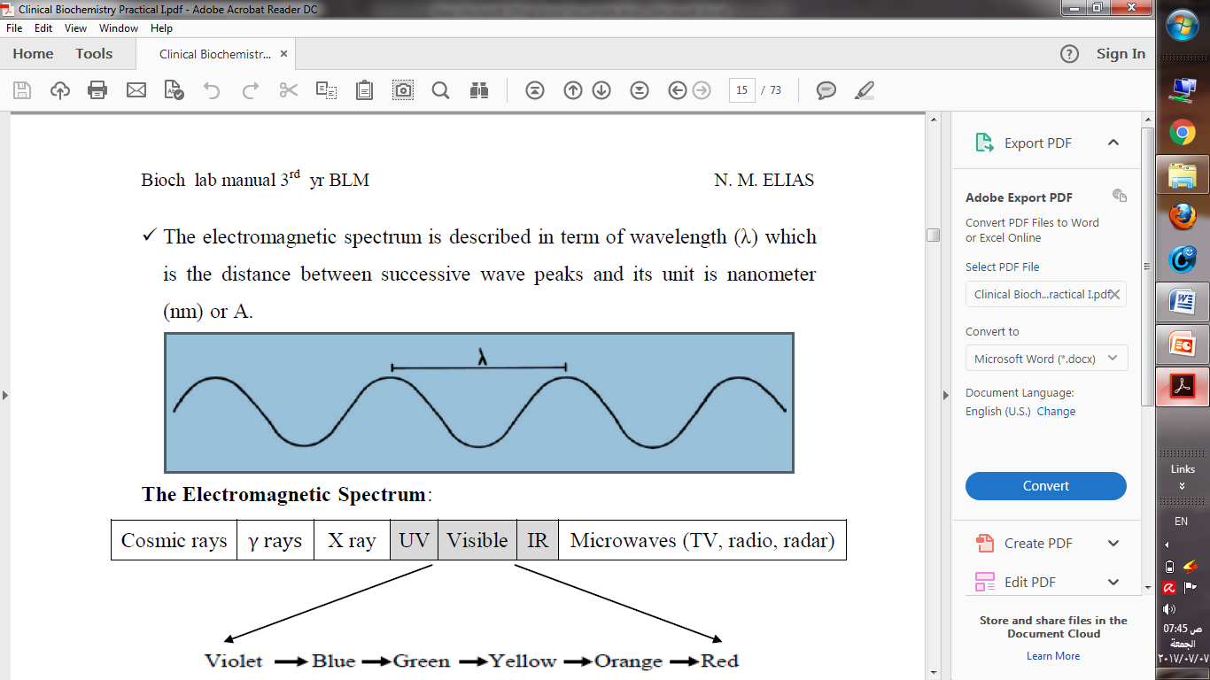

**Fig 2: The wavelength.**

It is the wavelength that determines the color of the light. The human eye can only see the wave­lengths of energy between about 380 and 720 nm. This is called the visible spectrum. The total light spectrum can be divided into three distinct regions-the ultraviolet region, the visible region and the infrared region (Fig. 3).

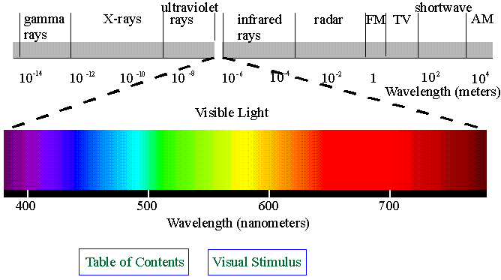

**Fig 3: The wavelength regions.**

Light whose wavelength is 380 nm is violet. Light with wavelength less than 380 nm is not visible to the human eye and is known as ultraviolet. Light with wavelengths of more than 720 is not visible and is known as infrared light. The visible spectrum occurs between the wavelengths of 380 and 720 nm. White light is seen colorless, it is composed of all colors of the visible spectrum.

**The color** of a substance will depend on the wavelength absorbed by the substance and which are transmitted to the observer's eye.

**Beer's Law**

When a colored solution is passed with monochromatic light, its absorbance is directly proportional to the concentration of the colored solution when the light path is constant.

Absorbance α Concentration

(When light path length is constant)

**Lambert's Law**

When a colored solution is passed with light, its absorbance is directly proportional to the length of light path when concentration of the solution is constant.

Absorbance α Length

(When concentration is constant).

If we combine both we get the Beer Lambert's Law; When a colored solution passed with monochromatic light, its absorbance is proportional to the concentration of the colored solution and the length of the light path."

Absorbance α Concentration and Length

**Calculation of Absorbance (A)**

Usually colorimeters measure transmittance rather than absorbance.

Transmittance and Absorbance has an inverse relationship.

T is the ratio of intensity of emergent light (I) to the intensity of incident light (IO)

T = I / Io

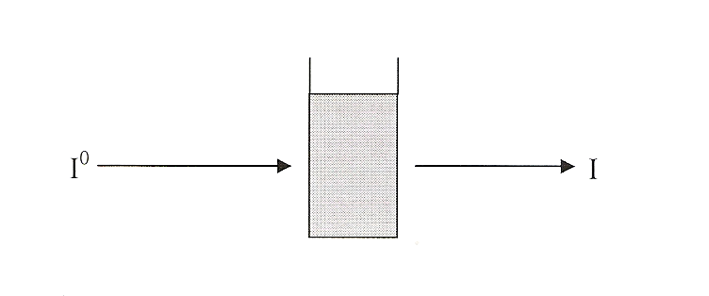

In clinical chemistry, there are two ways of expressing the amount of light absorbed by a solution. These are:

**Amount Transmission (% T)**

Percent transmission is the amount of light, which passes through a colored solution compared to the amount of light, which passes through a blank or colorless solution. As the concentration of the colored solution increases the amount of light absorbed increases while the % T decreases

**Optical Density (OD)**

The OD may be calculated from the % T and is the units preferred in clinical chemistries, the reason OD is usually preferred is that there is a direct relationship between the concentrations of a solution and the OD i.e. as the concentration of a solution increases, the absorbance or OD also increases.

The concentration of the unknown is given by the formula:

Concentration unknown = OD unknown

Concentration standard = OD standard

Concentration unknown =OD unknown X Concentration of Std. OD standard

**Components of spectrophotometer:** Spectrophotometer is an instrument that is capable of measuring absorbance or transmittance of light (fig. 4). Spectrophotometer is generally composed of the following major components:

1. **Light source:** This part of the instruments emits visible or UV light depending on the source itself. For example a tungsten lamp emits light from 380-720 nm, while a deuterium lamp emits in the UV region.

Entrance slits: This part functions in passing a very fine beam of light and passing it to the monochromator.

1. **Monochromator:** This part is similar to a prism or a filter which function in isolating only one single light, i.e. one wavelength. The equipments that use filters for this purpose are referred to as filter Photometers whereas those that use prisms or gratings are called spectrophotometers.
2. **Exit slits:** This part functions in passing a very fine beam of isolated wavelength.
3. **Sample holder:**

* It's also known as cuvette or cell; made of glass, quartz or plastic.
* Glass and transparent plastic cuvettes are used in the visible region.
* Quartz or silica cell are necessary for UV radiation.
* Cuvettes are of two types – macrocuvettes with a capacity of 3 ml only and microcuvettes with a capacity of 1 ml only.

1. **Photo Cell (detector):** This part converts light energy to electric energy so it can be measured by the measuring device.

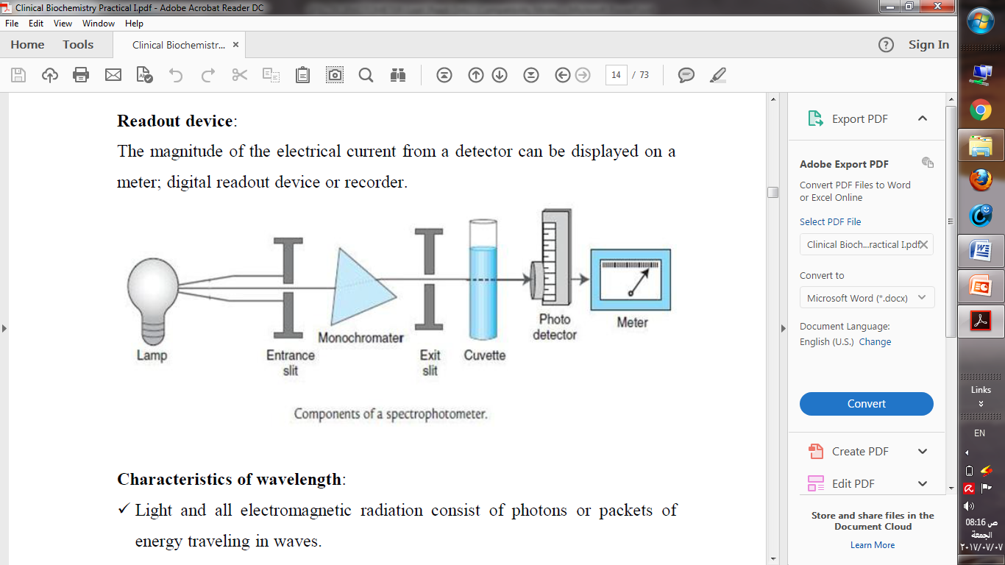

**Fig 4: Components of spectrophotometer**

**Requirements of Colorimetric Analysis:** When colorimetric determinations are made, it is essential to ensure that the color being measured is only due to the substance under investigation and is not due to any of the reagents used. It is, therefore, essential to include the following solutions.

**1. Test solution:** This contains the unknown concentration of the substance together with the reagents used in the test.

**2. Standard solution:** This is usually identical to the test solution, except that it contains a known amount of the substance being determined and is approximately equal in concentration to that expected in the test.

**3. Blank solution:** This solution is identical to both the test and standard solution and it is carried through the complete test procedure and contains all the reagents used, but without any test or standard substance. Any color given by the reagents used in the analysis can be detected and eliminated In order to be sure that the absorbance is due solely to the substance under test, the reading given by the 'blank' solution must be considered with the reading obtained from the 'test' and 'standard' solutions. The colorimeter or the spectrophotometer is set to read zero absorbance with distilled water.

**References**

Higuchi A. (2010): Separation and purification of stem and blood cells by porous polymeric membranes. In: Driolli E, Giorno L (eds) Comprehensive membrane science and engineering. Elsevier, Cambridge.

 Michael G. Gore (2000): Spectrophotometry & Spectrofluorimetry. New York: Oxford University.

**Websites**

* <http://www.ruf.rice.edu/~bioslabs/methods/protein/spectrophotometer.html>
* https://chem.libretexts.org/Core/Physical_and_Theoretical_Chemistry/Kinetics/Reaction_Rates/Experimental_Determination_of_Kinetcs/Spectrophotometry